Experiment No. 6
Student Name: Ojaswini Thote
PRN: 24070521048

Experiment Title
Use String Functions and Regular Expressions for Email Validation, Data Extraction, and Text Analysis

Software / Tools Required
- Visual Studio Code
- Google Chrome
- HTML5
- JavaScript (ES6)

Practical — Email Validation, Data Extraction and Text Analysis

Aim
To use JavaScript string functions and regular expressions for email validation, data extraction, and text analysis.

File Path
EXP 6/Practical/index.html
EXP 6/Practical/script.js

Program Code

EXP 6/Practical/index.html
<!DOCTYPE html>
<html lang="en">
<head>
<meta charset="UTF-8">
<meta name="viewport" content="width=device-width, initial-scale=1.0">

<title>String Functions and Regex</title>

<style>
body {
font-family: Arial, sans-serif;
background: #ffe6f2;
padding: 30px;
}

.container {
max-width: 800px;
margin: auto;
background: white;
padding: 30px;
border-radius: 12px;
box-shadow: 0 4px 15px rgba(0,0,0,0.2);
}

h1 {
text-align: center;
}

h2 {
margin-top: 30px;
}

input, textarea {
width: 100%;
padding: 10px;
margin-top: 8px;
border: 1px solid #ccc;
border-radius: 6px;
box-sizing: border-box;
}

button {
margin-top: 10px;
padding: 10px 20px;
background: #d63384;
color: white;
border: none;
border-radius: 6px;
cursor: pointer;
}

.result {
margin-top: 15px;
padding: 15px;
background: #fff0f6;
border-radius: 8px;
}
</style>
</head>

<body>

<div class="container">

<h1>String Functions and Regex</h1>

<h2>1. Email Validation</h2>

<input type="text" id="email" placeholder="Enter your email">

<button onclick="validateEmail()">
Validate Email
</button>

<div class="result" id="emailResult"></div>

<h2>2. Data Extraction</h2>

<textarea
id="data"
rows="4"
placeholder="Enter text containing numbers">
</textarea>

<button onclick="extractData()">
Extract Numbers
</button>

<div class="result" id="dataResult"></div>

<h2>3. Text Analysis</h2>

<textarea
id="text"
rows="5"
placeholder="Enter text for analysis">
</textarea>

<button onclick="analyzeText()">
Analyze Text
</button>

<div class="result" id="textResult"></div>

</div>

<script src="script.js"></script>

</body>
</html>

EXP 6/Practical/script.js
// Email Validation using Regular Expression

function validateEmail() {

let email = document.getElementById("email").value.trim();

let emailPattern =
/^[^\s@]+@[^\s@]+\.[^\s@]+$/;

let result =
document.getElementById("emailResult");

if (emailPattern.test(email)) {

result.innerHTML =
"<b>Valid Email Address</b>";

} else {

result.innerHTML =
"<b>Invalid Email Address</b>";
}
}

// Data Extraction using Regular Expression

function extractData() {

let data =
document.getElementById("data").value;

let numbers =
data.match(/\d+/g);

let result =
document.getElementById("dataResult");

if (numbers) {

result.innerHTML =
"<b>Extracted Numbers:</b> " +
numbers.join(", ");

} else {

result.innerHTML =
"No numbers found.";
}
}

// Text Analysis using String Functions

function analyzeText() {

let text =
document.getElementById("text").value.trim();

let result =
document.getElementById("textResult");

let characters =
text.length;

let words =
text === ""
? 0
: text.split(/\s+/).length;

let uppercase =
text.toUpperCase();

let lowercase =
text.toLowerCase();

result.innerHTML = `
<b>Number of Characters:</b> ${characters}<br>
<b>Number of Words:</b> ${words}<br>
<b>Uppercase:</b> ${uppercase}<br>
<b>Lowercase:</b> ${lowercase}
`;
}

String Functions and Regex Used
Function / Regex | Purpose
trim() | Removes extra spaces from the beginning and end
length | Finds the number of characters
split() | Splits text into words
toUpperCase() | Converts text to uppercase
toLowerCase() | Converts text to lowercase
test() | Tests whether an email matches the regex pattern
match() | Extracts matching data from text
/^[^\s@]+@[^\s@]+\.[^\s@]+$/ | Validates email format
/\d+/g | Extracts numbers from text

Output
The program performs the following operations:
- Validates whether the entered email address is valid or invalid.
- Extracts numbers from the given text using regular expressions.
- Counts the number of characters and words.
- Converts the text into uppercase and lowercase.

Screenshot
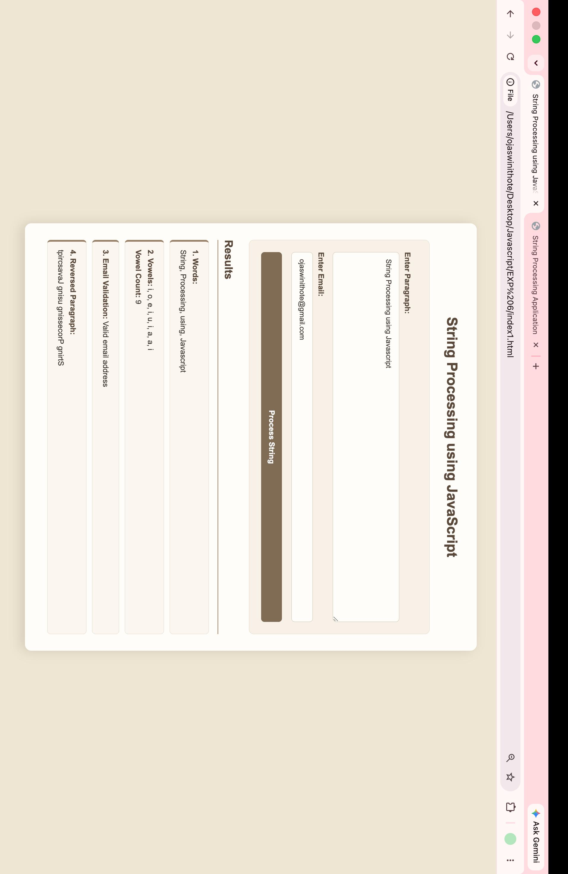

Case Study — Email Validation and Vowel Count

Aim
To use JavaScript string functions and regular expressions for email validation and counting vowels in a given text.

File Path
EXP 6/Case Study/index.html
EXP 6/Case Study/script.js

Program Code

EXP 6/Case Study/index.html
<!DOCTYPE html>
<html lang="en">
<head>
<meta charset="UTF-8">
<meta name="viewport" content="width=device-width, initial-scale=1.0">

<title>Email Validation and Vowel Count</title>

<style>
body {
font-family: Arial, sans-serif;
background: #f0f4ff;
padding: 30px;
}

.container {
max-width: 700px;
margin: auto;
background: white;
padding: 30px;
border-radius: 12px;
box-shadow: 0 4px 15px rgba(0,0,0,0.2);
}

h1 {
text-align: center;
}

input, textarea {
width: 100%;
padding: 10px;
margin-top: 10px;
box-sizing: border-box;
border: 1px solid #ccc;
border-radius: 6px;
}

button {
margin-top: 10px;
padding: 10px 20px;
background: #4f46e5;
color: white;
border: none;
border-radius: 6px;
cursor: pointer;
}

.result {
margin-top: 15px;
padding: 15px;
background: #eef2ff;
border-radius: 8px;
}
</style>
</head>

<body>

<div class="container">

<h1>Email Validation and Vowel Count</h1>

<h2>Email Validation</h2>

<input
type="text"
id="email"
placeholder="Enter your email address"
>

<button onclick="checkEmail()">
Validate Email
</button>

<div class="result" id="emailResult"></div>

<h2>Vowel Count</h2>

<textarea
id="text"
rows="5"
placeholder="Enter text here">
</textarea>

<button onclick="countVowels()">
Count Vowels
</button>

<div class="result" id="vowelResult"></div>

<hr>

<p>
<b>Name:</b> Ojaswini Thote
&nbsp; | &nbsp;
<b>PRN:</b> 24070521048
</p>

</div>

<script src="script.js"></script>

</body>
</html>

EXP 6/Case Study/script.js
// Email Validation

function checkEmail() {

let email =
document.getElementById("email").value.trim();

let emailPattern =
/^[^\s@]+@[^\s@]+\.[^\s@]+$/;

let result =
document.getElementById("emailResult");

if (emailPattern.test(email)) {

result.innerHTML =
"<b>Valid Email Address</b>";

} else {

result.innerHTML =
"<b>Invalid Email Address</b>";
}
}

// Vowel Count using Regular Expression

function countVowels() {

let text =
document.getElementById("text").value;

let vowels =
text.match(/[aeiou]/gi);

let count =
vowels ? vowels.length : 0;

document.getElementById(
"vowelResult"
).innerHTML =
"<b>Total Number of Vowels:</b> " +
count;
}

String Functions and Regex Used
Function / Regex | Purpose
trim() | Removes unnecessary spaces
test() | Checks whether the email matches the regex pattern
match() | Finds vowels in the entered text
length | Counts the number of matched vowels
/^[^\s@]+@[^\s@]+\.[^\s@]+$/ | Validates email format
/[aeiou]/gi | Finds all vowels, ignoring case

Output
The Case Study performs the following operations:
- Validates the email address entered by the user.
- Displays whether the email is valid or invalid.
- Accepts a text input from the user.
- Counts the total number of vowels in the text.
- Displays the vowel count dynamically.

Screenshot
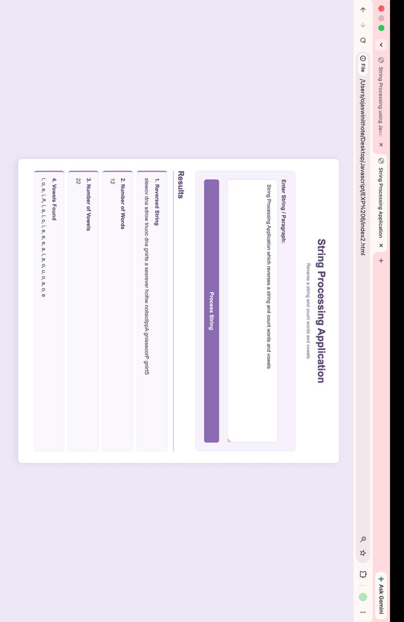

Result / Conclusion
The experiment was completed successfully.
The Practical demonstrated the use of JavaScript string functions and regular expressions for email validation, data extraction, and text analysis. Functions such as trim(), split(), toUpperCase(), toLowerCase(), match(), and test() were used.
The Case Study demonstrated the practical use of regular expressions for email validation and vowel counting. The program successfully validated user email addresses and counted vowels from the given text.
Thus, the experiment successfully demonstrated the use of String Functions and Regular Expressions in JavaScript.

